**PROJECT REPORT**

**DATABASE MANAGEMENT SYSTEM**

**Topic: Airport Management System**

**Group-7**

**Submitted by:**

Praneeth Reddy Kunam | AP20110010643

Anil Kumar Kagitha | AP20110010654

Saipriya Vemuri | AP20110010671

Vinod Kumar Ainala | AP20110010673

Sravya Voruganti | Ap20110010678

**Under the guidance of : Dr .Priyanka**

**AIRPORT MANAGEMENT SYSTEM**

Table of Contents

**Table of contents2**

**Abstract3**

**Introduction3**

**Objective4**

**ER Diagram5**

**Information of Entities6**

City6

Airport6

Airline6

Flight6

Ticket7

Employee7

Passenger7

**Relationship among entities8**

City and Airport8

Airport And Airline8

Airport And Employee8

Airline And Flight8

Flight And Passenger9

Passenger And Ticket10

**Functional Dependencies10**

**Normalisation11**

Tables after normalisation11

**SQL Queries14**

**Conclusion19**

**AIRPORT MANAGEMENT SYSTEM**

**Abstract:**

The airport database management system consists of different airports present in different cities. Airport has many airlines consists information like airline id, airline name and code for each airline.

Assuming each city has one airport. Each airport has many employees working in it. We store employee details like name, address, job, phone, age etc. Airline has many flights and these flights can be non-stop or connecting. We keep track of flights, arrival and departure times etc. Each flight carries many passengers. Passengers need to book the tickets. So we store personal details of passengers like passenger, name, phone, age, passport number, along with the status of tickets like booking and cancellation of tickets.

**Introduction:**

This airport database management system consists developing of entities and their respective attributes. After forming initial entities and attributes we design the relationship among the entities means how each entity is related to other. We find the cardinality of entities. After computing each of the components we design suitable ER or EER diagram that contains each functionalities mentioned above. scheduling of flights, managing different service provided airplanes with respect to its terminals, Bookings of flights, details of passengers are the main aspects that are covered under this project .

This database can handle different requests and provides an output based on above entities. The results from this database is used by airport authorities for better decision making scheduling of flights, managing different service provided airplanes with respect to its terminals,

Bookings of flights, details of passengers are the main aspects that are covered under this project .

**Objective:**

The main objective of the project is to learn and implement a real-time application on database for airport database management system. The project, concentrates on bookings, tracking the flights . This Database will be a great solution for many functionalities in Airport.

**ER Diagram:**



**Information of Entities:**

There are seven entities present in our ER diagram with attributes connected to them.

**City:**

Attributes: Cname , State, Country

Assuming each city has only one airport. City name, state and country details are stores under entity named city. In these attributes Cname is a primary key which helps to identify city uniquely.

**Airport:**

Attributes: Airport_name , State, Country

Airport name, state and country details are stores under entity “Airport”. In these attributes Airport _name is a primary key which helps to identify Airport uniquely.

**Airline:**

Attributes: Airline ID , Airline _name, Code

An airport contains many airlines and information like airline id, airline name and code of airline will be stored. Among these attributes airline id acts as a primary key.

**Flight:**

Attributes: Source, Destination, Arrival, Departure, Status, Duration, Flighttype, Flight_code.

An airline contains many flights. To keep track of all flights, we store the arrival, departure timings, source and destination, Flight type and flight code, status for each flight. Among these attributes, Flight_code acts as primary key.

**Ticket:**

Attributes: Ticket_Number, price, source, destination, class, seatNo, Date_of_Travel

Each passenger knows the information of ticket. A passenger can either book or cancel the ticket. From this entity, a passenger able to know Ticket_Number, Price, Source, destination, class, seatNo, Date_of_Travel. Ticket_Number is the primary key which helps to identify Ticket uniquely.

**Employee:**

Attributes: First name, Last name, M, SSN, Sex, Address, Phone, Age, Salary, Job type.

An airport can have many employees and each employee belong to only one airport. Employees details like name in the form of First name , Last name and personal details like phone, age, sex, salary, job type, address, SSN will be stored. SSN is the primary key used to identify the employee uniquely.

**Passenger:**

Attributes: Fname, Lname, address, M, sex, age, passport_no, PID, phone

Each flight carries many passengers. We store personal details of the passengers such as name as first name, last name, address, sex, age, M, phone, PID and passportNo in case of international journey. In these passportNo and PID are primary keys used to identify the passenger uniquely.

**Relationship among entities:**

**1.City and Airport:**

Relation used: has

Assuming each city has one airport and an airport belongs to one city. It follows one-to-one relationship. This represents partial participation of both city and airport in a relation ‘has’.

has

1 1

airport

city

**2.Airport and Airline:**

Relation used: contains

Each airport contains many airlines and a single airline can be present in many airports. So it follows many-to-many relation. This represents total participation of airline and partial participation of airport in a relation contains.

contains

m n

Airline

Airport

**3.Airport and Employee:**

Relation used: has

Each airport has many employees working in it and one employee must belong to only one airport. It follows one-to-many relation. This represents total participation of airport and partial participation of employee in a relation ‘has’.

has

1 n

Airport

Employee

**4.Airline and Flight:**

Relation used: has

Each airline has many flights but a flight should belong to only one airline. It follows one-to-many relation. This represents total participation of both airline and flight in a relation ‘has’.

has

1 n

Flight

Airline

**5. Flight and Passenger:**

Relation used: carries

Each flight carries many passengers and each passenger belongs to only one flight. It follows one-to-many relation**.** This represents total participation of both Flight and Passenger in a relation ‘carries’.

carries

1 n

Passenger

Flight

**6. Passenger and Ticket:**

Relation used: books,cancels

Each passenger can either book or cancels the ticket. Passenger can book or cancel many tickets but a single ticket belongs to only one passenger. It follows one-to-many relation. This represents total participation of Ticket and partial participation of ‘Passenger’ in a relation ‘books’, and partial participation of both Passenger and Ticket in a relation ‘cancels.

books

1 n

Ticket

Passenger

cancels

1 n

**Functional dependencies:**

|  |  |  |
| --- | --- | --- |
|  | **Functional dependencies** | **Normal forms** |
| PASSPORTNO->FNAME,M,LNAME, ADDRESS, PHONE, AGE, SEX | Partial dependency | Violates 2NF |
| PID -> FLIGHT_CODE | Partial dependency | Violates 2NF |
| DATE_OF_BOOKING,SOURCE, DESTINATION, CLASS -> PRICE | Transitive dependency | Violates 3NF |
| DATE_OF_CANCELLATION -> SURCHARGE | Transitive dependency | Violates 3NF |
| JOBTYPE -> SALARY | Transitive dependency | Violates 3NF |

**Normalization:**

Some of the tables having partial dependency and come tables have transitive dependency. Due to these functional dependencies, we may not get accurate result. To reduce data redundancy, we follow’s normalisation:

2NF: to remove partial dependency

3NF: to remove transitive dependency

All the tables converted into **3NF**, to reduce transitive dependency. The tables become:

**TABLES AFTER NORMALISATION:**

**CITY (CNAME, STATE, COUNTRY)**

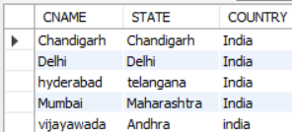

**AIRPORT (AP_NAME, STATE, COUNTRY, CNAME)**

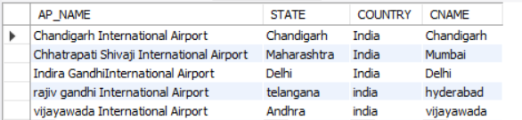

**AIRLINE (AIRLINEID, AL_NAME, THREE_DIGIT_CODE)**

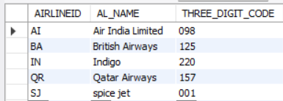

**FLIGHT (FLIGHT_CODE, SOURCE, DESTINATION, ARRIVAL, DEPARTURE, STATUS, DURATION, FLIGHTTYPE, LAYOVER_TIME, NO_OF_STOPS, AIRLINEID)**

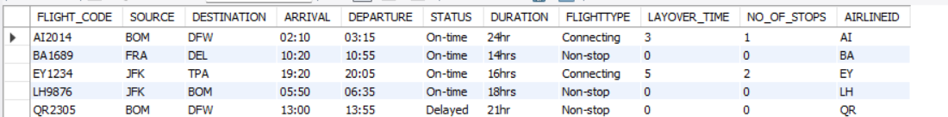

**PASSENGER1 (PID, PASSPORTNO)**

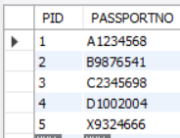

**PASSENGER2(PASSPORTNO, FNAME, M, LNAME, ADDRESS, PHONE, AGE, SEX)**

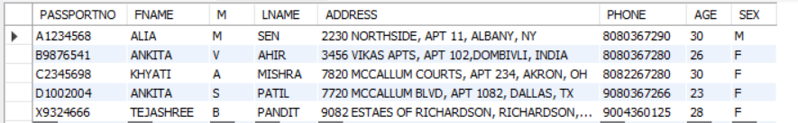

**PASSENGER3 (PID, FLIGHT_CODE)**

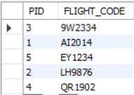

**EMPLOYEE1 (SSN, FNAME, M, LNAME, ADDRESS, PHONE, AGE, SEX, JOBTYPE, ASTYPE, ETYPE, SHIFT, POSITION, AP_NAME)**



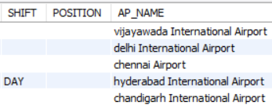

**EMPLOYEE2(JOBTYPE, SALARY)**

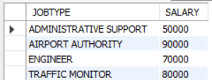

**SERVES (SSN, PID, PASSPORTNO)**

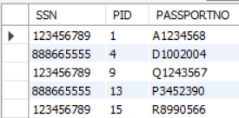

**TICKET1(TICKET_NUMBER,SOURCE,DESTINATION,DATE_OF_BOOKING,DATE_OF_TRAVEL,SEATNO,CLASS,DATE_OF_CANCELLATION,PID,PASSPORTNO)**

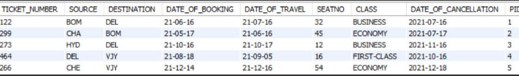

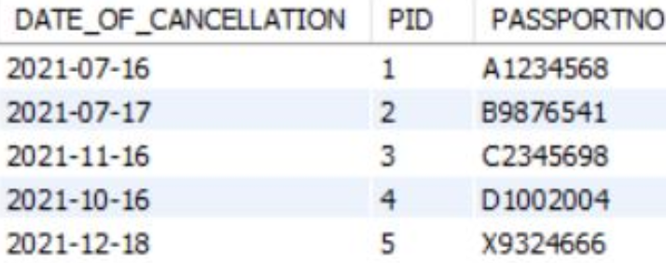

**TICKET2 (DATE_OF_BOOKING, SOURCE, DESTINATION, CLASS, PRICE)**

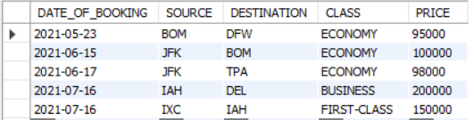

**TICKET3 (DATE_OF_CANCELLATION, SURCHARGE)**

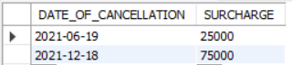

**SQL QUERIES:**

create database airport;

use airport;

CREATE TABLE CITY (CNAME VARCHAR(15) NOT NULL,

                    STATE VARCHAR(15),

                    COUNTRY VARCHAR(30),

                    PRIMARY KEY(CNAME));

INSERT INTO CITY (CNAME, STATE, COUNTRY) VALUES('hyderabad','telangana','India');

INSERT INTO CITY (CNAME, STATE, COUNTRY) VALUES ('Chandigarh','Chandigarh','India');

INSERT INTO CITY (CNAME, STATE, COUNTRY) VALUES ('vijayawada','Andhra','india');

INSERT INTO CITY (CNAME, STATE, COUNTRY) VALUES('Delhi','Delhi','India');

INSERT INTO CITY (CNAME, STATE, COUNTRY) VALUES('Mumbai','Maharashtra','India');

SELECT * FROM CITY;

CREATE TABLE AIRPORT(AP_NAME VARCHAR(100) NOT NULL,

                    STATE VARCHAR(15),

                    COUNTRY VARCHAR(30),

                    CNAME VARCHAR(15),

                    PRIMARY KEY(AP_NAME),

                    FOREIGN KEY(CNAME) REFERENCES CITY(CNAME) ON DELETE CASCADE);

INSERT INTO AIRPORT (AP_NAME, STATE, COUNTRY, CNAME) VALUES('rajiv gandhi International Airport','telangana','india','hyderabad');

INSERT INTO AIRPORT (AP_NAME, STATE, COUNTRY, CNAME) VALUES('Chandigarh International Airport','Chandigarh','India','Chandigarh');

INSERT INTO AIRPORT (AP_NAME, STATE, COUNTRY, CNAME) VALUES('vijayawada International Airport','Andhra','india','vijayawada');

INSERT INTO AIRPORT (AP_NAME, STATE, COUNTRY, CNAME) VALUES('Indira GandhiInternational Airport','Delhi','India','Delhi');

INSERT INTO AIRPORT (AP_NAME, STATE, COUNTRY, CNAME) VALUES('Chhatrapati Shivaji International Airport','Maharashtra','India','Mumbai');

SELECT * FROM AIRPORT;

CREATE TABLE AIRLINE(AIRLINEID VARCHAR(3) NOT NULL,

                    AL_NAME VARCHAR(50),

                    THREE_DIGIT_CODE VARCHAR(3),

                    PRIMARY KEY(AIRLINEID));

INSERT INTO AIRLINE (AIRLINEID, AL_NAME, THREE_DIGIT_CODE) VALUES('SJ','spice jet','001');

INSERT INTO AIRLINE (AIRLINEID, AL_NAME, THREE_DIGIT_CODE) VALUES('AI','Air India Limited','098');

INSERT INTO AIRLINE (AIRLINEID, AL_NAME, THREE_DIGIT_CODE) VALUES('IN','Indigo', '220');

INSERT INTO AIRLINE (AIRLINEID, AL_NAME, THREE_DIGIT_CODE) VALUES('BA','British Airways','125');

INSERT INTO AIRLINE (AIRLINEID, AL_NAME, THREE_DIGIT_CODE) VALUES('QR','Qatar Airways','157');

CREATE TABLE FLIGHT

(FLIGHT_CODE VARCHAR(10) NOT NULL,

SOURCE VARCHAR(3),

DESTINATION VARCHAR(3),

ARRIVAL VARCHAR(10),

DEPARTURE VARCHAR(10),

STATUS VARCHAR(10),

DURATION VARCHAR(30),

FLIGHTTYPE VARCHAR(10),

LAYOVER_TIME VARCHAR(30),

NO_OF_STOPS INT,

AIRLINEID VARCHAR(3),

PRIMARY KEY(FLIGHT_CODE),

FOREIGN KEY(AIRLINEID) REFERENCES AIRLINE(AIRLINEID) ON DELETE CASCADE);

INSERT INTO FLIGHT VALUES('AI2014','BOM','DFW','02:10','03:15','On-time','24hr','Connecting',3,1,'AI');

INSERT INTO FLIGHT VALUES('QR2305','BOM','DFW','13:00','13:55','Delayed','21hr','Non-stop',0,0,'QR');

INSERT INTO FLIGHT VALUES('EY1234','JFK','TPA','19:20','20:05','On-time','16hrs','Connecting',5,2,'EY');

INSERT INTO FLIGHT VALUES('LH9876','JFK','BOM','05:50','06:35','On-time','18hrs','Non-stop',0,0,'LH');

INSERT INTO FLIGHT VALUES('BA1689','FRA','DEL','10:20','10:55','On-time','14hrs','Non-stop',0,0,'BA');

SELECT * FROM FLIGHT;

SET FOREIGN_KEY_CHECKS=0;

CREATE TABLE PASSENGER1

(PID INT NOT NULL,

PASSPORTNO VARCHAR(10) NOT NULL,

PRIMARY KEY(PID, PASSPORTNO));

INSERT INTO PASSENGER1(PID, PASSPORTNO) VALUES(1,'A1234568');

INSERT INTO PASSENGER1(PID, PASSPORTNO) VALUES(2,'B9876541');

INSERT INTO PASSENGER1(PID, PASSPORTNO) VALUES(3,'C2345698');

INSERT INTO PASSENGER1(PID, PASSPORTNO) VALUES(4,'D1002004');

INSERT INTO PASSENGER1(PID, PASSPORTNO) VALUES(5,'X9324666');

SELECT * FROM PASSENGER1;

CREATE TABLE PASSENGER2

(PASSPORTNO VARCHAR(10) NOT NULL,

FNAME VARCHAR(20),

M VARCHAR(1),

LNAME VARCHAR(20),

ADDRESS VARCHAR(100),

PHONE LONG,

AGE INT,

SEX VARCHAR(1),

PRIMARY KEY(PASSPORTNO));

INSERT INTO PASSENGER2 VALUES('A1234568','ALIA','M','SEN','2230 NORTHSIDE, APT 11, ALBANY, NY',8080367290,30,'M');

INSERT INTO PASSENGER2 VALUES('B9876541','ANKITA','V','AHIR','3456 VIKAS APTS, APT 102,DOMBIVLI, INDIA',8080367280,26,'F');

INSERT INTO PASSENGER2 VALUES('C2345698','KHYATI','A','MISHRA','7820 MCCALLUM COURTS, APT 234, AKRON, OH',8082267280,30,'F');

INSERT INTO PASSENGER2 VALUES('D1002004','ANKITA','S','PATIL','7720 MCCALLUM BLVD, APT 1082, DALLAS, TX',9080367266,23,'F');

INSERT INTO PASSENGER2 VALUES('X9324666','TEJASHREE','B','PANDIT','9082 ESTAES OF RICHARDSON, RICHARDSON, TX',9004360125,28,'F');

SELECT * FROM PASSENGER2;

CREATE TABLE TICKET1

(TICKET_NUMBER BIGINT,

SOURCE VARCHAR(3),

DESTINATION VARCHAR(3),

DATE_OF_BOOKING varchar(20),

DATE_OF_TRAVEL varchar(20),

SEATNO INT,

CLASS VARCHAR(15),

DATE_OF_CANCELLATION DATE,

PID INT,

PASSPORTNO VARCHAR(10),

FOREIGN KEY(PID, PASSPORTNO) REFERENCES PASSENGER1(PID, PASSPORTNO) ON DELETE CASCADE);

INSERT INTO TICKET1 VALUES(122,'BOM','DEL','21-06-16','21-07-16',32,'BUSINESS','2021-07-16',1,'A1234568');

INSERT INTO TICKET1 VALUES(299,'CHA','BOM','21-05-17','21-06-16', ,45,'ECONOMY','2021-07-17',2,'B9876541');

INSERT INTO TICKET1 VALUES(273,'HYD','DEL','21-10-16','21-10-17',12,'BUSINESS','2021-11-16',3,'C2345698');

INSERT INTO TICKET1 VALUES(464,'DEL','VJY','21-08-18','21-09-05',16,'FIRST-CLASS','2021-10-16',4,'D1002004');

INSERT INTO TICKET1 VALUES(266,'CHE','VJY','21-12-14','21-12-16',54,'ECONOMY','2021-12-18',5,'X9324666');

SELECT * FROM TICKET1;

CREATE TABLE PASSENGER3

(PID INT NOT NULL,

FLIGHT_CODE VARCHAR(10),

PRIMARY KEY(PID),

FOREIGN KEY(FLIGHT_CODE) REFERENCES FLIGHT(FLIGHT_CODE) ON DELETE CASCADE);

INSERT INTO PASSENGER3(PID, FLIGHT_CODE) VALUES(1,'AI2014');

INSERT INTO PASSENGER3(PID, FLIGHT_CODE) VALUES(2,'LH9876');

INSERT INTO PASSENGER3(PID, FLIGHT_CODE) VALUES(3,'9W2334');

INSERT INTO PASSENGER3(PID, FLIGHT_CODE) VALUES(4,'QR1902');

INSERT INTO PASSENGER3(PID, FLIGHT_CODE) VALUES(5,'EY1234');

SELECT * FROM PASSENGER3;

CREATE TABLE EMPLOYEE1

(SSN INT NOT NULL,

FNAME VARCHAR(20),

M VARCHAR(1),

LNAME VARCHAR(20),

ADDRESS VARCHAR(100),

PHONE BIGINT,

AGE INT,

SEX VARCHAR(1),

JOBTYPE VARCHAR(30),

ASTYPE VARCHAR(30),

ETYPE VARCHAR(30),

SHIFT VARCHAR(20),

POSITION VARCHAR(30),

AP_NAME VARCHAR(100),

PRIMARY KEY(SSN),

FOREIGN KEY(AP_NAME) REFERENCES AIRPORT(AP_NAME) ON DELETE CASCADE);

INSERT INTO EMPLOYEE1 VALUES(123456789,'LINDA','M','GOODMAN','731 Fondren, Houston, TX',4356789345, 35, 'F','ADMINISTRATIVE SUPPORT','RECEPTIONIST','','','','vijayawada International Airport');

INSERT INTO EMPLOYEE1 VALUES(333445555,'JOHNY','N','PAUL','638 Voss, Houston, TX',9834561995, 40, 'M','ADMINISTRATIVE SUPPORT','SECRETARY','','','','delhi International Airport');

INSERT INTO EMPLOYEE1 VALUES(999887777,'JAMES','P','BOND','3321 Castle, Spring, TX',9834666995, 50, 'M','ENGINEER','','RADIO ENGINEER','','','chandigarh International Airport');

INSERT INTO EMPLOYEE1 VALUES(987654321,'SHERLOCK','A','HOLMES','123 TOP HILL, SAN Francisco,CA',8089654321, 47, 'M','TRAFFIC MONITOR','','','DAY','','hyderabad International Airport');

INSERT INTO EMPLOYEE1 VALUES(666884444,'SHELDON','A','COOPER','345 CHERRY PARK, HESSE,GERMANY',1254678903, 55, 'M','TRAFFIC MONITOR','','NIGHT','','','chennai Airport');

SELECT * FROM EMPLOYEE1;

CREATE TABLE EMPLOYEE2

(JOBTYPE VARCHAR(30) NOT NULL,

SALARY INT,

PRIMARY KEY(JOBTYPE));

INSERT INTO EMPLOYEE2(JOBTYPE, SALARY)VALUES('ADMINISTRATIVE SUPPORT',50000);

INSERT INTO EMPLOYEE2(JOBTYPE, SALARY)VALUES('ENGINEER',70000);

INSERT INTO EMPLOYEE2(JOBTYPE, SALARY)VALUES('TRAFFIC MONITOR',80000);

INSERT INTO EMPLOYEE2(JOBTYPE, SALARY)VALUES('AIRPORT AUTHORITY',90000);

SELECT * FROM EMPLOYEE2;

CREATE TABLE SERVES

(SSN INT NOT NULL,

PID INT NOT NULL,

PASSPORTNO VARCHAR(10) NOT NULL,

PRIMARY KEY(SSN, PID, PASSPORTNO),

FOREIGN KEY(SSN) REFERENCES EMPLOYEE1(SSN) ON DELETE CASCADE,

FOREIGN KEY(PID, PASSPORTNO) REFERENCES PASSENGER1(PID, PASSPORTNO) ON DELETE CASCADE);

INSERT INTO SERVES(SSN, PID, PASSPORTNO) VALUES(123456789,1,'A1234568');

INSERT INTO SERVES(SSN, PID, PASSPORTNO) VALUES(123456789,15,'R8990566');

INSERT INTO SERVES(SSN, PID, PASSPORTNO) VALUES(123456789,9,'Q1243567');

INSERT INTO SERVES(SSN, PID, PASSPORTNO) VALUES(888665555,4,'D1002004');

INSERT INTO SERVES(SSN, PID, PASSPORTNO) VALUES(888665555,13,'P3452390');

SELECT * FROM SERVES;

CREATE TABLE TICKET2

(DATE_OF_BOOKING DATE NOT NULL,

SOURCE VARCHAR(3) NOT NULL,

DESTINATION VARCHAR(3) NOT NULL,

CLASS VARCHAR(15) NOT NULL,

PRICE INT,

PRIMARY KEY(DATE_OF_BOOKING, SOURCE, DESTINATION, CLASS));

INSERT INTO TICKET2 VALUES('21-05-23','BOM','DFW','ECONOMY',95000);

INSERT INTO TICKET2 VALUES('21-06-15','JFK','BOM','ECONOMY',100000);

INSERT INTO TICKET2 VALUES('21-07-16','IAH','DEL','BUSINESS',200000);

INSERT INTO TICKET2 VALUES('21-07-16','IXC','IAH','FIRST-CLASS',150000);

INSERT INTO TICKET2 VALUES('21-06-17','JFK','TPA','ECONOMY',98000);

SELECT * FROM TICKET2;

CREATE TABLE TICKET3

(DATE_OF_CANCELLATION DATE NOT NULL,

SURCHARGE INT,

PRIMARY KEY(DATE_OF_CANCELLATION));

INSERT INTO TICKET3(DATE_OF_CANCELLATION, SURCHARGE) VALUES('21-12-18',75000);

INSERT INTO TICKET3(DATE_OF_CANCELLATION, SURCHARGE) VALUES('21-06-19',25000);

**CONCLUSION:**

This database helps us to store the data related to the airport management system which consists of every information related to airlines, airport, employees working in the airport, flight details like timings of arrival, departure, information related to tickets like status, booking and cancellation of tickets. We also mentioned the relations between entities along with the cardinality. These information helps the airport management system to retrieve the data whenever they want. Since it contains large data, we may come across data redundancy. So, after applying normalisation, we remove partial and transitive dependency for the data we considered. Now the database is in 3NF.